Dear valued customer,
In order to fulfil the requirements of ISO 9001 and similar standards, DWK Life Sciences understands the importance of supplier qualification and evaluation programs for your company. Due to the high demand and intricacy of the surveys, at this time DWK is not able to complete each customer-provided survey. This document was developed to cover all aspects of DWK's Integrated Management System (IMS). By providing this pre-filled questionnaire, long response times can be avoided, and inquiries will be answered immediately. This standard questionnaire is applicable to DWK Life Sciences operations in North America.

If there are any questions not answered in this Self-Audit, please do not hesitate to contact us at: quality@dwk.com

Contents
Part 1 – General company information 2
Part 2 –Contact Information 2
Part 3 – DWK operations worldwide and their business focus: 3
Part 4 – ISO compliance / certification status DWK sites worldwide 4
Part 5 – Quality Assurance 5
Part 6 – Environmental, Social, Governance (ESG) and EHS Information 7
Part 7 – Regulatory Information 8
Part 8 – FAQs 9
Appendix 1: List of DWK Policies and Procedures 10

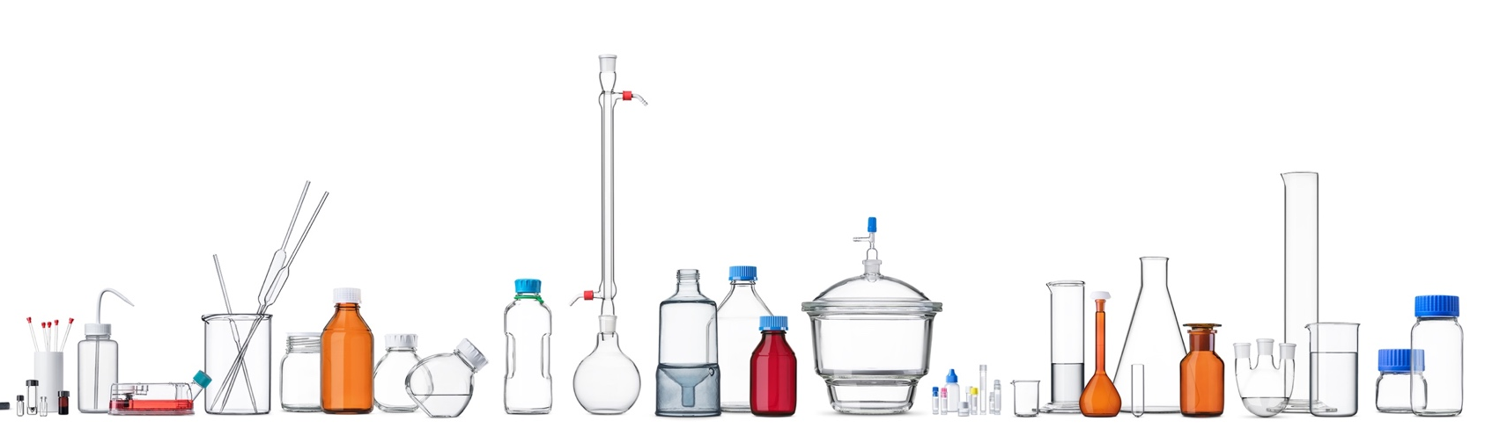

Part 1 – General company information
Company Name | DWK Life Sciences
At a glance | - A portfolio company of ONE EQUITY PARTNERS  - A leading global manufacturer of premium scientific labware and solutions for a wide range of life science, storage, and technical applications.  - Owner of the highly recognized brands DURAN®, WHEATON®, KIMBLE®, and Müller + Müller ®  - 1,800 employees worldwide  - Sales totaling 300,000,000 EUR in 2023
Our vision | We will be present in every laboratory and production environment around the world and will accelerate scientific progress by providing a full range of products and solutions for customers in drug discovery, life science, pharma packaging, and industrial markets.
Product and service offerings | - Over 35,000 laboratory and industrial products  - Solutions for storage and packaging  - Customization capabilities  - Post Processing Premium Services
Web URL | https://www.dwk.com/na/
Years in operation | ~ 130 years
Type of business | Manufacturer, Distributor, and Assembler
Corporate Management
CEO, DWK LLC | Jeff Schempp
VP, Global Quality | Alexander Cross
VP, Sales | Scott Roler
Director, Customer Service | Geri Skinner
Site-Specific
New Jersey Sites | Quality: Anton Stetsenko Operations: Gene Concordia
Rockwood, TN | Quality: Ronald Hall Operations: Jason Surgenor
Queretaro, Mexico | Quality: Pablo Gutierrez Operations: Janette Granados

Part 2 –Contact Information
Customer Service: | us.customerservice@dwk.com
Quality: | quality@dwk.com
Certificates: | certrequest.na@dwk.com
Compliance and Regulatory: | compliance.na@dwk.com
Sustainability and ESG: | esg@dwk.com

Part 3 – DWK operations worldwide and their business focus:
DWK Life Sciences LLC (North America)
Corporate address | 228 West Landis Avenue, Vineland, NJ, 08360, US (Suite 100)  - Corporate management for North America, including Customer Service, Supply Chain, Engineering, and Quality Management.  - Size of site: 3.700 m² Employees: 30  - 1 Shift, M-F, 08:00 – 17:00 EST  - ISO Accreditation: ISO 9001  - In-House Certification: ISO 50001, 14001, 45001
Site addresses | 234 Cardiff Valley Road, Rockwood, Tennessee, 37854, US  - Manufacturing and processing of glass for culture tubes, test tubes, vials, and pipettes.  - Size of site: 21.000 m² Employees: 230  - 24/7, shifts vary by department  - ISO Accreditation: ISO 9001, 15378  - In-House Certification: ISO 50001, 14001, 45001
Site addresses | 1501 N. 10th Street, Millville, New Jersey 08332, US  - Warehousing; distribution; manufacturing of culture flasks and lab equipment; repack and assembly.  - Size of site: 11.400m² Employees: 100  - 2 Shifts, M-F, 06:00 – 14:30, 14:30 – 23:00 EST  - ISO Accreditation: ISO 9001  - In-House Certification: ISO 50001, 14001, 45001
Site addresses | 1649 Castpa Place, Vineland, New Jersey 08360, US (“DWK Life Sciences Closure Systems, LLC”)  - Manufacturing of rubber stoppers and aluminum seals; assembly, printing, glass washing, and glass inspection services.  - Size of site: 5.600 m² Employees: 90  - 3 Shifts, M-F, varies by department  - ISO Accreditation: Pending ISO 9001, planned for 2026  - In-House Certification: ISO 9001, 50001, 14001, 45001
Site addresses | 578 Crystal Avenue, Bldg 202, Vineland, New Jersey 08360, US  - Warehousing and distribution.  - Size of site: 9.200 m² Employees: 10  - 1 Shift, M-F, 07:00 – 15:30 EST  - ISO Accreditation: ISO 9001  - In-House Certification: ISO 50001, 14001, 45001
Site addresses | 600 Orange Street, Millville, New Jersey 08332, US  - Warehousing.  - Size of site: 6.500 m² Employees: 3  - 1 Shift, M-F, 06:00 – 14:30 EST  - ISO Accreditation: ISO 9001  - In-House Certification: ISO 50001, 14001, 45001
Site addresses | DWK Life Sciences, S. de. R. L. de. C.V., Querétaro, MX  - Manufacturing and processing of laboratory glassware.  - Size of site:8.000m² Employees: 290  - 3 shifts, 7 days/week, 06:00 - 14:00, 14:00 - 23:00, 23:00 - 06:00 CST  - ISO Accreditation: ISO 9001, 17025  - In-House Certification: ISO 50001, 14001, 45001
DWK Life Sciences GmbH (Europe)
Corporate address | DURAN Glastechnik GmbH & Co. KG, Otto-Schott-Str. 21, 97877 Wertheim/Main, Germany  - Production and processing of laboratory glass and industrial products.  - Size of site: 10.614 m² Employees: 150  - ISO Accreditation: ISO 9001, 50001  - In-House Certification: ISO 14001, 45001
Site addresses | DURAN Produktions GmbH & Co. KG, Hattenbergstr. 10, 55122 Mainz, Germany  - Melting furnace for the production of laboratory glass and consumer glass products.  - Size of site: 19.000 m² Employees: 220  - ISO Accreditation: ISO 9001, 50001  - In-House Certification: ISO 14001, 45001
Site addresses | DURAN d.d., Mazuraniceva 3, 52100 Pula, Croatia  - Melting furnace for the production of laboratory glass and industrial products.  - Size of site: 16.000 m² Employees: 240  - ISO Accreditation: ISO 9001, 50001, 14001  - In-House Certification: ISO 45001
Site addresses | Scherf Präzision Europa GmbH, Herpfer Strasse 31, D-98617 Meiningen, Germany  - Production and processing of laboratory glassware including test tubes, bottle inserts, and pipettes.  - Size of site: 2.500m² Employees: 60  - ISO Accreditation: ISO 9001  - In-House Certification: ISO 50001, 14001, 45001
Müller + Müller-Joh. GmbH + Co. KG, Weseraue 1, 37603 Holzminden
- Manufacturing and processing of tubular glass, especially serum and roll neck vials.
- Size of site: 13,000 m² Employees: 150
- ISO Accreditation: ISO 9001, 15378
- In-House Certification: ISO 50001, 14001, 45001
DWK Life Sciences Limited (UK)
Corporate address | Unit 4, Riverside 2, Campbell Road, Stoke-on-Trent, ST4 4RJ, UK
Site addresses | 4 Gordon Banks Drive, Trentham Lakes North, Stoke-on-Trent, ST4 4TW, UK  - Manufacturer of laboratory and diagnostic glassware; distributor of laboratory/diagnostic plasticware.  - Size of site: 3000m2 Employees: 140  - ISO Accreditation: ISO 9001, 13485, 17025, 15378  - In-House Certification: ISO 50001, 14001, 45001

Part 4 – ISO compliance / certification status DWK sites worldwide
DWK Life Sciences has implemented a worldwide Integrated Management System (IMS) to ensure methods and instruments meet requirements from various areas (e.g., quality, environmental protection and occupational safety, security, and energy) in a uniform structure.
Site certificates are available at https://www.dwk.com/na/iso-certifications.

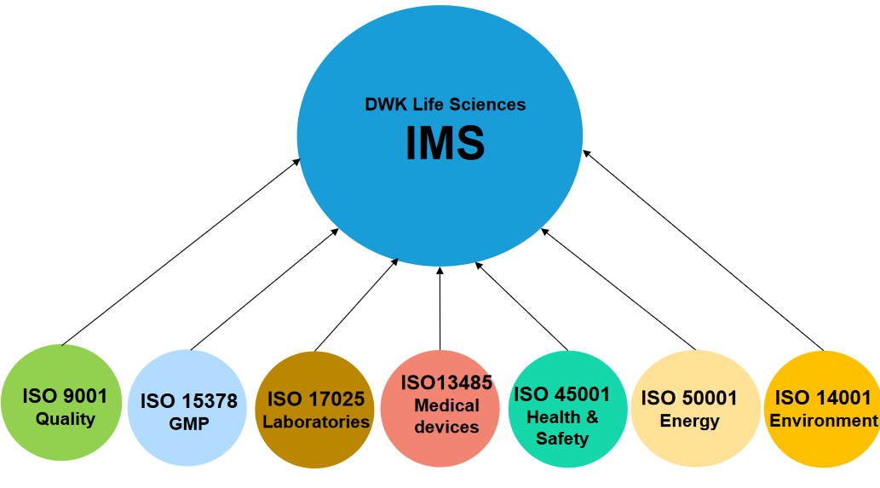

Part 5 – Quality Assurance

Quality Policy | Available at https://www.dwk.com/quality-standards
Site specific ISO Certificates | Available at https://www.dwk.com/iso-certifications
Code of Conduct | Available at https://www.dwk.com/na/health-safety

Key Process Information
Certificates | Certificates are included with specific items or according to customer requirements. Depending on the individual item type, DWK can provide a certificate of compliance, analysis, processing, irradiation, etc. Certificates are issued by Quality.  Certificates can be requested via email: certrequest.na@dwk.com
Change Control | SOP: 32215 “Engineering Change Control”  All changes are reviewed by Quality, Engineering, and other relevant departments.  Customer notification is provided according to individual Quality Agreements.  Custom items cannot be changed without written customer approval.
Crisis Management | Business Continuity Plans are in place and include requirements for immediate actions, damage assessment, and recovery. Specific response plans and contacts differ by site.
Customer Complaints | SOP: 4558 “Customer Complaint Management”  Complaints are investigated and tracked. When applicable, CAPAs and Supplier Corrective Action Reports (SCARs) are issued to address the root cause.
Data Integrity | SOP: 4678 “IT Use Policy”  All employees are subject to the IT Use Policy and controls related to passwords and authentication.
Deviations and CAPAs | SOP: 7155 “Deviations and CAPAs”  Deviations are initiated in response to nonconformities. Based on the assessed risk level, a CAPA will be initiated to implement further actions and assess effectiveness after implementation.  Product deviations must be approved by Quality and Engineering management, as well as any other impacted departments. Customer approval is obtained for customer-specific items or orders.
Document Control | SOP: 7043 “Document and Record Management”  The document retention period is 10 years or as required by local laws/regulations. All controlled documents (SOPs, WIs, Forms) are reviewed and approved by department heads and Quality prior to issuance.
Good Documentation Practices | SOP: 7250 “Good Documentation Practices”  All facilities are required to follow GDP. Employees receive annual refresher training.
IMS (Quality) Manual | SOP: 7438 “DWK-GP-Integrated Management System”  The IMS is applicable to all DWK sites globally. Employees receive annual training on the IMS and applicable standards (ISO, cGMP, etc.).
Incoming, In-Process, and Final Inspections | SOP: 64602 “Inspections and Control of Non-Conforming Ware”  Inspections are according to ANSI/ASQ Z1.4 special inspection level S4 or General Level II (site-dependent). Accept/Reject is according to internal AQL levels, based on product type. Quality is responsible for final release.
Internal Audits | SOP: 6884 “Internal Audit Procedure”  Each department/site is audited annually. Auditors must complete a certification course and must be independent of the area being audited.
Management Review | SOP: 7046 “Management Review”  Management reviews are performed annually with top management and department heads. Action items are tracked and CAPAs issued for any nonconformities.
Measuring Devices and Equipment | SOP: 7041 “Calibration, Preventive Maintenance, and Equipment Management”  Equipment that is out of calibration is identified and removed from use until calibration is restored.  External calibration providers must be approved and certified to ISO 17025. Internal calibrations are performed according to site-specific procedures by qualified personnel.
Non-conforming Product | SOP: 64602 “Inspections and Control of Non-Conforming Ware”  Product pending inspection is placed on hold and segregated until released by Quality. Storage areas are separate and controlled to prevent mixing of product.  Quality has authority to stop production if a nonconformity is identified. Reworked product is subject to Quality inspection prior to release.
Pest Control and Facilities | SOP: 6991 “General Facilities Maintenance”  Pest control is performed monthly at minimum. Results are reviewed monthly.
Production Controls | SOP: 7047 “Product Identification and Traceability”  While production processes are generally site-specific, for all sites:  - Production personnel use written procedures  - Line clearances are performed  Manufacturing can be continuous or by campaign, depending on the item.  For sites with an ISO Class 7 or Class 8 cleanroom, recertification is performed annually. Cleanroom procedures are site-specific.
Product Recall | SOP: 5910 “Product Recall & Recovery”  Mock recalls are conducted every 3 years minimum.
Risk Assessment | SOP: 4559 “Risk Assessment”  Risk assessments are conducted for all major processes (FMEAs) and during investigations for Deviations and CAPAs.
Supplier Qualification | SOP: 7191 “Supplier Evaluation and Qualification”  New suppliers must be approved by Quality. Suppliers and service providers are audited at regular intervals according to criticality.
Training | SOP: 4557 “Learning Management”  In addition to job-specific training, employees receive annual ISO/Quality awareness training. This includes ISO 9001:2015, review of key DWK policies, Good Documentation Practices, and additional site-specific requirements (GMP, ISO 15378, etc.).
Validations | SOP: 7400 “Validation Master Plan”  Validation requirements are site-dependent, according to facility ISO certifications and the intended use of the item.
Warehousing | While warehouse procedures are site-specific, for all sites:  - Raw materials are used on a “first-in first-out basis (FIFO)  - All wooden pallets are required to be heat-treated  - Product is protected from moisture, damage, and direct light



Part 6 – Environmental, Social, Governance (ESG) and EHS Information
EHS Policy | https://www.dwk.com/na/health-safety
Conflict Minerals Statement | https://www.dwk.com/na/health-safety
Social Responsibility (Employment and Remuneration, Equal Opportunities Policy, Human Rights Policy) | https://www.dwk.com/na/social-responsibility
Sustainability | https://www.dwk.com/na/sustainability
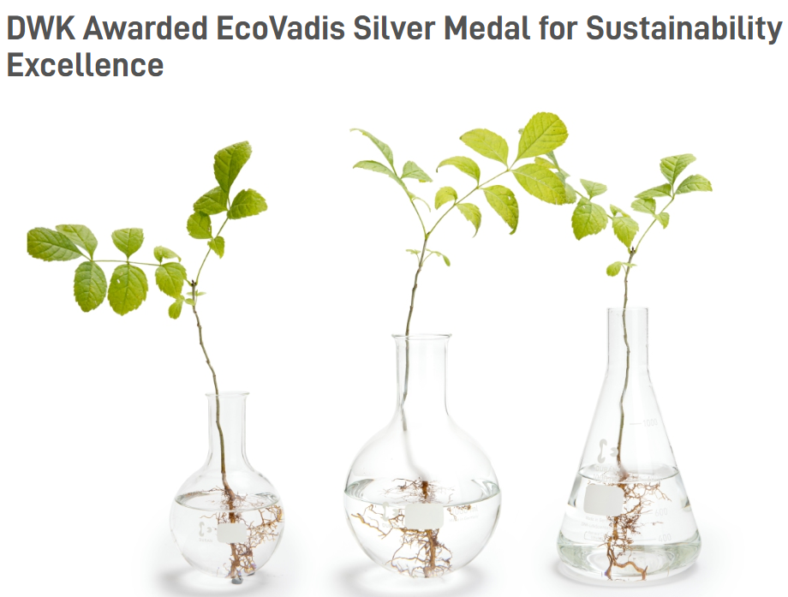
Press Release: https://www.dwk.com/na/news-events/press-releases/dwk-awarded-ecovadis-silver-medal-for-sustainability-excellence

Part 7 – Regulatory Information
FDA Registration | Only the Rockwood, TN site is FDA registered.  ID number: 3006808300
Drug Master Files (DMFs) | Drug Master Files for DWK Life Sciences are available for the following products:  - DWK Rockwood Type I glass vials (DMF 39109)  - DWK Closure Systems stoppers and seals (DMF 24097)  - DURAN PURE premium lip seal cap (DMF 31063)  - DURAN PURE premium screw cap (DMF 28044)  - DURAN PURE bottles clear and amber (DMF 28042)  Please contact compliance.na@dwk.com to request a Letter of Authorization for the items listed above, or to request DMF information on other products (e.g. manufactured by third party).
Shelf Life and Expiration | Shelf life and expiration dates are item dependent.
BSE/TSE | All glass products are free from nonconforming animal derivatives.  BSE/TSE information for all non-glass items can be supplied upon request.
Glass | - Type I Borosilicate Glass – meets the requirements for the current revisions of USP <660> and EP 3.2.1 for hydrolytic resistance and arsenic extraction.  - Type III Soda Lime Glass – meets the requirements for the current revisions of the USP <660> and EP 3.2.1 for hydrolytic resistance and arsenic extraction.  - Heavy Metals – Heavy metals are not intentionally added to glass compositions. Thus, contents of lead, cadmium, mercury, and hexavalent chrome are in compliance with the limit values of 100 ppm by weight for US (TPCH and CONEG) and EC regulations.
Additional Information | Item-specific regulatory information can be supplied upon request: compliance.na@dwk.com.  A selection of technical papers and other resources is available at: https://www.dwk.com/na/resources

Part 8 – FAQs
Is DWK willing to accommodate customer audits? | Yes, dependent on the product history and Quality Agreements. DWK recommends at least 3 months’ notice to ensure availability.
Is DWK audited by the FDA? | No, DWK is not subject to audits from the FDA or any other governmental agencies.
Is a third party audit available? | No, at this time DWK does not have a third-party audit available for review or purchase. To arrange an audit, contact quality@dwk.com.
Is a Non-Disclosure Agreement mandatory? | Yes, in the case of a customer audit or when confidential information is shared. Template available upon request.
Can a Quality Agreement be put in place? | Yes. Template available upon request.
Can DWK provide change notifications? | Yes, DWK can provide change notifications according to individual Quality Agreements. For custom items, change approval requests are sent prior to change implementation.
Can DWK provide copies of its Quality Manual, SOPs, or Organizational Chart? | Due to confidentiality, DWK is unable to share most internal documents. These documents are available for review during an onsite or live remote audit.

Appendix 1: List of DWK Policies and Procedures
Doc# | Title
Level I
7438 | DMS-GP-Integrated Management System
427 | DWK-GP-Operating Performance System
Level II
54758 | 6S, Housekeeping, and Safety Audits
55667 | Access Control Plan
6374 | AQL Sampling Procedure
7101 | Backup Policy
52495 | Business Continuity Plan – NJ Sites
7041 | Calibration Preventive Maintenance and Equipment Management
103803 | CapEx ESG Evaluation
57249 | Closing Production Orders in SAP
4609 | Control of Hardware and Software
5712 | Completing SCARs
63320 | Control of Records
4665 | Customer Communication Handling
4558 | Customer Complaint Management
4561 | Customer Feedback Analysis
7042 | Customer Satisfaction Performance Index
64185 | Customer Specifications
7155 | Deviations and CAPAs
105063 | DMFs (Drug Master Files)
7043 | Document and Record Management
7173 | Document Control in SharePoint
56862 | Employee Hiring and Termination
32215 | Engineering Change Control
52754 | Engineering Document Request
56724 | Engineering Project Request Document Control
63427 | GagePack Calibration and PM
6991 | General Facilities Maintenance
7250 | Good Documentation Practices
68644 | Housekeeping WI – NJ Warehouses
64602 | Inspections and Control of Non-Conforming Ware
6884 | Internal Audit Procedure
7156 | Internal Communication
5703 | IT Office and Server Room Security
4678 | IT Use Policy
4679 | Job Descriptions
4557 | Learning Management
64430 | Legal and Regulatory Requirements
57282 | Loading and Unloading Trailers
7046 | Management Review
4683 | Network Password Policy
5911 | Non-Disclosure Agreements
66775 | Process SAP Quotes
7047 | Product Identification and Traceability
5621 | Product Label Formatting Guideline
53287 | Product Management ECN Customer Notification
5910 | Product Recall & Recovery
4576 | Public Relations and Media Policy
4559 | Risk Assessment
69671 | Safety Manual
69136 | Safety Manual – EHS and Managers
104367 | Salesforce
65017 | Suggestion Program
7191 | Supplier Evaluation and Qualification
7400 | Validation Master Plan

Site-Specific Work Instructions/Procedures list available upon request.

